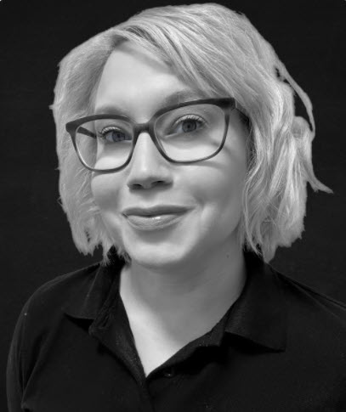

Rhian Slaymaker – ClearCorrect Practice Implementation Specialist
Rhian started as a trainee dental nurse at a private practice in Reading in 2001, passing her NEBDN exams in 2004.
In 2007 Rhian travelled to Uganda with 10 other dental professionals and volunteered in pop up dental clinics delivering emergency dental treatment and oral health education to over 2000 people in the month they were there. It was here that Rhian could see the benefits of having a variety of skill mix across the dental team.
Rhian has since gained additional qualifications in Dental Radiography, Oral Health Education & Promotion as well as impression, shade taking and Treatment Co-ordination. Over the past 20 years in dentistry Rhian has worked in multiple practices including working for a dental agency in the West Midlands and one of the largest global commercial dental groups as a Dental nurse and Treatment Co-ordinator. Rhian joined the Clear Correct Team in 2021 as our First Level Support she has now moved into the position of Practice Implementation Specialist. Rhian has a passion for learning personally but also in others, especially empowering dental nurses to expand their knowledge, gaining additional skills and clinicians being able to utilise the varied skill mix in the practice. Rhian enjoys city breaks, is a very competitive when playing a board game and enjoys spending time with her Husband and son.
Rhian is also on the Panel of Representatives for the BADN (British Association of Dental Nurses).

